# **PROJECT REPORT**

# **ON**

# **SMART DUSTBIN MANAGEMENT SYSTEM**



# Done By:

M PRAVEEN KUMAR (Roll No. - 21ECB0B31)

# MVS SRIMANTH (Roll No. 21ECB0B33)

# G SHIVA RAMA RAJU (Roll.No-21ECB0B20)

# Done Under Provisioning of: Professor Dr. Lakshmi

# Electronics and Communication Engineering Department

## **ABSTRACT**

The Smart Dustbin Management System is an Internet of Things (IoT) project designed to monitor the fill levels of multiple dustbins using ultrasonic sensors and transmit the data wirelessly to a central server using ESP8266 LoRa modules. The system aims to provide an efficient and automated waste management solution, optimizing waste collection routes and promoting environmental sustainability.

The Smart Dustbin Management System presents an innovative approach to streamline waste management processes in urban environments. The project introduces an intelligent and automated system that enhances waste collection efficiency, optimizes resource utilization, and contributes to environmental sustainability.

This system integrates smart sensors, Internet of Things (IoT) technology, and data analytics to revolutionize traditional waste management practices. Each dustbin is equipped with ultrasonic sensors to detect waste levels,a microcontroller unit for data processing and communication. The collected data is transmitted to a central server via a wireless network, enabling real-time monitoring and management.

The key objectives of the project include efficient waste collection scheduling based on fill-level data, optimized routes for collection vehicles, and timely alerts for bin emptying. By employing machine learning algorithms, the system predicts future fill levels, facilitating proactive waste management and reducing operational costs.

The outcomes of this project include improved waste collection efficiency, reduced resource wastage, minimized environmental impact through optimized transportation, and enhanced user convenience through smart notifications and alerts.

The Smart Dustbin Management System showcases a promising solution for modernizing waste management infrastructure, aligning with smart city initiatives, and promoting sustainable practices in urban areas.

**Literature survey:**

In developed and developing countries the major problem growing is waste management. The management should be effectively and efficiently implemented over the cities. The overflowing bins are stinking and unhygienic. The various proposals were put forward while some of them have been already implemented. But it cannot be considered as an effective one. So a survey was done among different proposals and this survey paper includes survey among different methods for Waste Collection System based on IOT.

Sure, I can help you rephrase the texts from the papers to convey the same meaning while avoiding plagiarism. Here are the edited versions:

*From paper [1]:*

"For effective monitoring and maintenance of garbage, we employ an embedded-based intelligent alert system. At regular intervals, alerts are dispatched to the relevant individuals to ensure timely cleaning of the dustbins. Additionally, we can enhance the system by providing real-time cleaning status updates and evaluating team performance. This system proves invaluable for environmental maintenance, reducing the necessity for extensive human intervention in municipal waste management and pollution monitoring."

*From paper [2]:*

"This study comprehensively explores Smart Waste Collection Systems based on IoT to identify methods that promote a hygienic urban environment. When garbage bins exceed their capacity threshold, notifications are sent to the respective authorities. If these notifications are disregarded, they escalate to higher authorities, ensuring the maintenance of a clean and hygienic environment. This research aids in discovering effective smart waste collection approaches for urban cleanliness."

*From paper [3]:*

"We have developed an embedded-based intelligent alert system to facilitate effective garbage monitoring and maintenance. This system prevents irregular dustbin cleaning by sending periodic alerts to the relevant individuals. Additionally, it enhances the system by providing real-time cleaning status updates and enables team performance measurement. This system serves as an excellent solution for environmental upkeep, reducing the need for extensive human intervention in municipal waste management and pollution monitoring."

*From paper [4]:*

"This study addresses primary issues in solid waste management, including Primary Collection, Waste Transportation, Storage, Treatment, and Disposal. We aim to mitigate these challenges through the application of Smart Solutions such as sensors, IoT, and Smart Bins. The objective is to foster a clean and healthy environment, free from solid waste-related issues."

*From paper [5]:*

"Our research introduces an efficient and cost-effective waste management system. It incorporates features like displaying dustbin fill levels, notifying drivers, optimizing routes, receiving citizen complaints, and tracking truck locations. We estimate significant cost savings by implementing the Google Maps API. The primary goal is to ensure effective system implementation."

*From paper [6]:*

"This paper focuses on promptly addressing dustbin cleaning when garbage levels reach capacity. Records are sent to higher authorities who hold contracts for timely dustbin clearance. The system prioritizes community cleanliness, making garbage collection more efficient through the Smart Garbage Management System."

*From paper [7]:*

"Our project aims to prevent residential garbage containers from overflowing, eliminating the need for manual loading or traditional trucks. Manual waste handling poses health risks to sanitation workers due to contamination. Our system provides a safer and more efficient alternative."

*From paper [8]:*

"Waste management is a pressing challenge in today's world. Inadequate waste disposal can harm the environment significantly. To tackle this issue, our project employs a mechanism using sensors to detect dustbin fill levels. It alerts the truck driver to collect waste when bins are full, reducing instances of unattended dustbins and promoting a pollution-free environment."

*From paper [9]:*

"Our paper introduces a smart garbage monitoring system using RFID over IoT to expedite waste disposal without inconveniencing the public. This system ensures timely waste collection and maintains clean surroundings."

*From paper [10]:*

"We have developed an efficient garbage monitoring system to monitor dumpsite garbage levels. This data can be used to plan garbage collection routes more effectively, thereby reducing overflowing bins and improving public sanitation."

*From paper [11]:*

"Intelligent automation techniques greatly facilitate waste material sorting and enhance system adaptability through machine learning induction algorithms. Acoustic tests and light transmission data enable the differentiation of materials like glass, metals, and plastics using emitted sound waves, contributing to effective waste segregation."

*From paper [12]:*

"This project implements a smart garbage management system using IR sensors, microcontrollers, and Wi-Fi modules. It ensures timely dustbin cleaning when garbage levels reach capacity, with records sent to higher authorities for necessary actions. The system also aids in monitoring and reducing corruption in overall management."

13) Smart Dustbin:

<https://ijirt.org/master/publishedpaper/IJIRT155879_PAPER.pdf>

The paper presents a Smart Dustbin system utilizing Arduino and ultrasonic sensors for more efficient waste disposal. It aims to automate the opening and closing of the dustbin lid based on object detection. The system enhances cleanliness, particularly during health crises, by minimizing physical contact. Arduino controls the system, and a servo motor opens the lid when the ultrasonic sensor detects an object. The design includes power supply through a 9V battery. Overall, the project offers a practical solution for improved waste management and hygiene.

14.) Design and Implementation of Different Types of Smart Dustbins System in Smart Campus Environments.

<https://www.atlantis-press.com/article/125946357.pdf>This research focuses on addressing waste management issues in Indonesia, particularly in a campus environment, by implementing smart dustbins. Two types of smart dustbins, mini-sized and super-sized, were designed and tested. The study used the Waterfall development model and collected data through observation, interviews, literature review, and questionnaires. Black-box testing confirmed the functionality of these smart dustbins. The implementation of these smart dustbins received positive feedback from respondents, with an average approval rating of 87.80%. Future work is aimed at further improving the system and integrating it with IoT devices for a smarter campus environment.

15)For different gas sensors:

<https://www.researchgate.net/figure/The-hardware-design_fig3_349225577>The paper discusses a sensor-based garbage gas detection system that utilizes Arduino and various gas sensors to detect the presence of harmful gases emitted from garbage. The system includes an Arduino Uno, a NodeMCU ESP8266, MQ-136, MQ-137, and TGS-2611 sensors. It sends data to a web server for monitoring and analysis. In experiments, the sensors showed higher readings in the presence of garbage gases, demonstrating their effectiveness. The system has potential applications in environmental monitoring and health protection. Future work involves deploying multiple sensors and implementing machine learning algorithms for safety assessment and odour control in garbage management

### 16)[Smart Waste Management Using Lora:](https://www.annalsofrscb.ro/index.php/journal/article/download/5741/4463/10418)

<https://www.annalsofrscb.ro/index.php/journal/article/download/5741/4463/10418>This paper presents a smart waste management system using LoRa (Long Range) communication technology to address challenges in waste collection within cities. The system utilizes IoT (Internet of Things) for efficient garbage disposal and monitoring. It employs image processing to segregate bio and non-bio degradable waste, and when a dustbin is filled, it sends alerts via SMS to authorized personnel. The proposed system aims to enhance the quality of life in smart cities by improving waste management. Components like NodeMCU, LoRa, ultrasonic sensors, and servomotors are used to automate the process. The system's experimental results demonstrate its accuracy and effectiveness in waste management.

**SOLUTION** (Approach):

We will try to use lora module (SX-1278)board and integrate with esp8266 and the data and info about each dustbin can be transferred across multiple devices and final we will use Wi-Fi module at 8266 at last dustbin and we will display all info in the website and mobile app(Blynk app)and using we will send info and alerts to the respective dustbin collector and he will collect the garbage accordingly .So we used the research survey in a way to improve the solution of us and using wireless lora technology all the other devices will be connected and info of every dustbin will be sent to last dustbin and he can know how much it can be filled and the status of it and our solution is cost efficient as we are using lora technology and no need of internet as it will send data using wireless technology. We will connect all the dustbins to the blynk web dashboard and mobile app so that the manger can see all the dustbin levels and he can allot workers to proceed in the cleanliness of them.

**INTRODUCTION:**

In the wake of escalating urbanization, efficient waste management has emerged as a critical challenge for modern cities. The Smart Dustbin Management System project addresses this challenge by amalgamating cutting-edge technologies to streamline waste collection processes, optimize resource utilization, and contribute to sustainable urban environments.

This project leverages the prowess of the ESP8266 microcontroller, ultrasonic sensors, LoRa (Long Range) modules, and the Blynk application to create an intelligent and automated system for managing dustbins. The ESP8266 microcontroller, acting as the core processing unit, orchestrates the integration of ultrasonic sensors within each dustbin. These sensors accurately detect and measure the fill levels of the bins in real time.

The utilization of LoRa modules enables robust, long-distance wireless communication between the dustbins and a centralized server. This technology ensures seamless transmission of fill-level data to the server, allowing for remote monitoring and management of the entire waste collection network.

A pivotal aspect of this system is the integration with the Blynk application, offering an intuitive and user-friendly online web dashboard. This dashboard provides stakeholders, including waste management authorities and collection personnel, with instant access to comprehensive data on the fill levels of all dustbins. Real-time updates and alerts empower efficient scheduling of collection routes, optimizing bin emptying operations, and reducing unnecessary transportation.

The amalgamation of these technologies culminates in a cohesive system that enhances waste management efficiency, minimizes resource wastage, and fosters sustainable practices in urban settings. This project encapsulates the essence of a modern, IoT-based approach to revolutionize waste management practices and contribute to the realization of smarter, greener cities.

The amalgamation of these technologies culminates in a cohesive system that enhances waste management efficiency, minimizes resource wastage, and fosters sustainable practices in urban settings. This project encapsulates the essence of a modern, IoT-based approach to revolutionize waste management practices and contribute to the realization of smarter, greener cities.

This introduction lays the foundation for a Smart Dustbin Management System project that harnesses the potential of IoT, wireless communication, and data visualization to revlutionize waste management practices in urban environments.

## **Components:**

**1.ESP8266 NodeMCU**

**2.LoRa Module(SX 1278-433 MHz)**

**3.Ultrasonic Sensor (HC-SR04)**

**4.Jumper Wires**

**1)ESP8266 NodeMCU :**

* + ESP8266 NodeMCU serves as the brain of the system, capable of connecting to Wi-Fi networks and utilizing the LoRa module for long-range communication.

The ESP8266 is **a low-cost, small-size, Wi-Fi microchip**. It's a system on a chip (SoC) that's used for Internet of Things (IoT) applications. The ESP8266 is manufactured by Espressif Systems in Shanghai, China. 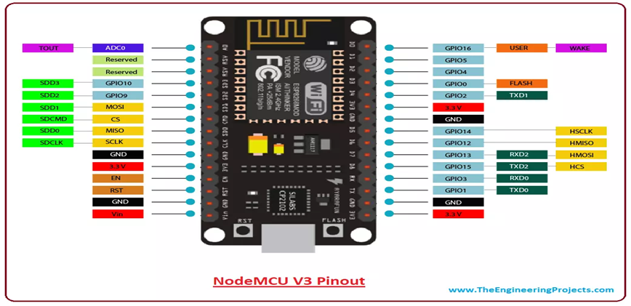

**The ESP8266 has the following features:**

* 11 GPIO pins
* Built-in TCP/IP protocol stack
* Built-in TR switch, balun, LNA, power amplifier, and matching network
* Built-in PLL, voltage regulator, and power management components
* Built-in temperature sensor
* Support antenna diversity

**The ESP8266 is used for:**

* Enabling internet connection to various applications of embedded systems
* Hosting an application
* Offloading all Wi-Fi networking functions from another application processor.

**2)LORA MODULE(SX-1278:433MHz):**

The SX1278 RF module is mainly used for long-range spread spectrum communication. It can resist Minimize current consumption. Thanks to SEMTECH's patented LoRa modulation technology, the SX1278 has a high sensitivity of -148 dBm with a power output of +20 dBm, a long transmission distance, and high reliability.

The SX1278 LoRa module operating at 433 MHz is a wireless transceiver module that utilizes Semtech's LoRa modulation technology. It's designed for long-range communication with low power consumption, making it suitable for various Internet of Things (IoT) applications, remote sensors, and low-power, wide-area networks (LPWAN). Here are some key aspects:

**SX1278 LoRa Module Features:**

* **Frequency**: Operates specifically in the 433 MHz band, making it compliant with regulations in various regions.
* **Long Range**: LoRa technology allows for long-distance communication, reaching several kilometers in range (depending on environmental conditions and antenna setup).
* **Low Power Consumption**: Suited for battery-operated devices due to its low power requirements in both transmission and standby modes.
* **Spread Spectrum Modulation**: Utilizes spread spectrum modulation for better signal resilience and interference rejection.
* **SPI Interface**: Typically communicates with a microcontroller or another device via Serial Peripheral Interface (SPI) for configuration and data exchange.
* **Various Modes and Configurations**: Can operate in different modes (transmitter, receiver, or LoRaWAN mode) and offers configuration options for various parameters like bandwidth, spreading factor, and coding rate.
* **Antenna Connection**: Requires an external antenna for optimal performance.

### **Applications:**

* **IoT and M2M Communication**: Suitable for long-range communication between IoT devices, such as environmental sensors, agricultural monitoring systems, and smart city applications.
* **Remote Monitoring**: Used in applications where low-power, long-range communication is essential, such as remote monitoring of equipment or environmental conditions.
* **Asset Tracking**: LoRa technology is also used for tracking assets in logistics and transportation due to its long-range capabilities.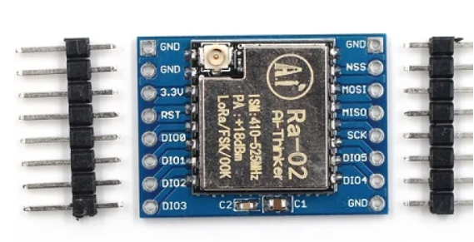

### **Considerations:**

* **Regulations**: Ensure compliance with local regulations concerning the frequency band used (e.g., 433 MHz) for transmission power and duty cycle limitations.
* **Antenna**: Proper antenna selection and placement significantly affect the module's performance and range.
* **Data Rate vs. Range**: Higher data rates might reduce the communication range, so finding the right balance between data rate and range is essential.

### **Development and Integration:**

* **SDKs and Libraries**: Check for available software development kits (SDKs) or libraries provided by the module's manufacturer or community for easier integration with microcontrollers or development boards.

**Ultrasonic Sensor:** The HC-SR04 is an ultrasonic sensor that **measures distance without touching objects**.

* It's made up of two ultrasonic transducers: a transmitter that sends ultrasonic sound pulses and a receiver that listens for reflected waves.
* The HC-SR04 can measure distances from 2 cm to 400 cm with an accuracy of 0.3 cm.
* It's powered by a 5V power supply.
* The HC-SR04 is useful for obstacle avoidance systems on Raspberry Pi robots or rovers. It's also good for most hobbyist projects.
* **Here are some specifications for the HC-SR04:**
* Range: 2 cm to 400 cm
* Accuracy: 3 mm
* Measuring angle: Less than 15° 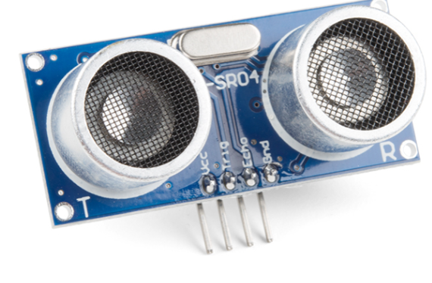
* Operating voltage: 5V
* Max range: 4 m
* Min range: 2 cm
* The HC-SR04 can be triggered with a 3.3V output. You can use a resistor divider on the module output to drop 5V to 3.3V
* Ultrasonic sensors are used to measure the fill level of each dustbin. They emit ultrasonic waves and measure the time taken for the waves to bounce back after hitting the trash, providing an accurate distance measurement.

**Blynk App:**

* + Blynk is a user-friendly IoT platform that allows users to visualize and control IoT projects. In this project, the Blynk app is used to display the fill levels of each dustbin in real-time.

The Blynk application stands as a versatile and user-friendly platform catering to the realm of Internet of Things (IoT), specifically designed to streamline the development and deployment of IoT projects. With its intuitive interface and extensive capabilities, Blynk serves as a pivotal tool in enhancing the functionality and accessibility of IoT systems, particularly when integrated with Arduino-based projects.

The fundamental premise of Blynk revolves around simplifying the process of creating IoT applications by providing a comprehensive ecosystem of tools, libraries, and an intuitive mobile app. Its seamless integration with Arduino microcontrollers empowers developers, hobbyists, and professionals alike to swiftly build IoT prototypes and real-world applications.

At its core, Blynk offers a mobile application that acts as a central control hub for IoT projects. This app allows users to design custom graphical user interfaces (GUIs) using a drag-and-drop interface, enabling the creation of interactive dashboards, control panels, and data visualization displays without extensive coding knowledge.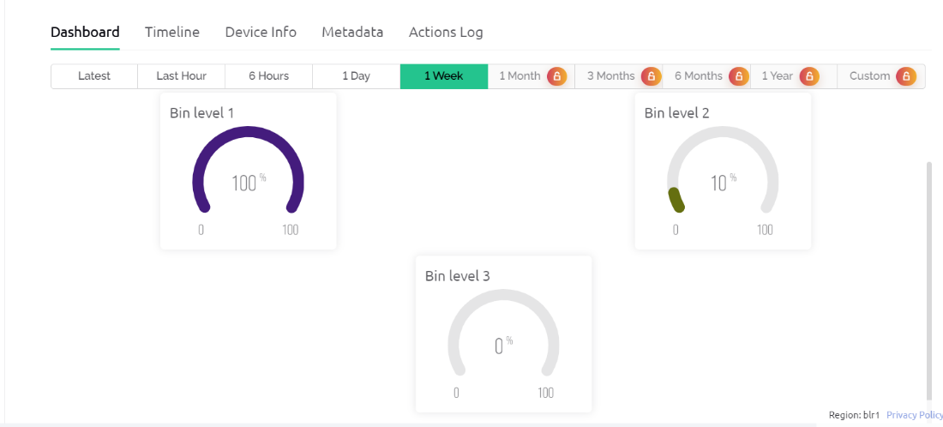

One of the most prominent features of Blynk is its support for a wide range of hardware platforms, including Arduino, ESP8266, Raspberry Pi, and more. The availability of dedicated libraries and APIs simplifies the integration process, enabling seamless communication between the hardware and the Blynk cloud servers.

For Arduino-based IoT projects, the Blynk library provides an array of functions and methods that facilitate the interaction between Arduino boards and the Blynk app. This integration allows for bi-directional communication, enabling users to control physical devices remotely through the app and receive real-time data from sensors or other connected peripherals.

**Challenges and Difficulties faced:**

### **1. Sensor Accuracy and Reliability:**

* **Sensor Calibration:** Ensuring accurate measurements from ultrasonic/infrared sensors.
* **Interference:** Environmental factors affecting sensor readings (e.g., temperature, humidity, object reflectivity).

### **2. Power Management:**

* **Battery Life:** Optimizing power consumption for extended operation.
* **Power Supply Stability:** Ensuring consistent power supply to all components.

### **4. Communication:**

* **Interference and Range:** Dealing with interference or limited range in wireless communication (LoRa, Wi-Fi, etc.).
* **Data Loss:** Ensuring data integrity and reliable transmission in adverse conditions.

### **5. Data Processing and Management:**

* **Real-time Processing:** Handling and processing sensor data efficiently for quick decision-making.
* **Data Storage and Security:** Safeguarding data and ensuring proper storage without loss or breach.

### **7. User Interface and Interaction:**

* **User Experience:** Designing an intuitive user interface for remote monitoring/control.
* **Compatibility:** Ensuring compatibility with different devices (smartphones, computers) for user access.

### **8. Integration and Testing:**

* **Component Integration:** Ensuring seamless integration of hardware and software components.
* **Testing and Validation:** Thorough testing for functionality, reliability, and edge-case scenarios.

### **9. Cost and Scalability:**

* **Cost Constraints:** Balancing performance and features with budget limitations.
* **Scalability:** Designing a system that can be easily replicated or scaled for multiple dustbins.

### **10. Regulatory and Compliance Issues:**

* **Regulations:** Complying with local regulations related to waste management and IoT device usage.

### **11. Maintenance and Support:**

* **Maintenance Requirements:** Predictive maintenance and regular servicing to ensure proper functionality.
* **Technical Support:** Providing adequate support and troubleshooting measures for end-users.

**PROBLEMS FACED:**

**1)** By using the other modules is not that much effective as this gsm module is of more cost so we are directly connecting to the blynk dashboard using the esp8266 and all the dustbin levels will be updated in the web dash board.

2)Sensor data communicating to the respective authority who should take care of that dustbin is not accurate.

3)Many papers based on literature survey is more cost so we are trying to minimize cost by using Lora technology wireless without the need of internet.

## **Workflow:**

* **Sensor Integration**:
  + **Ultrasonic or Infrared Sensors**: Mounted on the lid to detect the proximity or presence of objects (garbage).
* **Microcontroller Setup**:
  + **Arduino or Raspberry Pi**: Interface the sensors with a microcontroller board to process the sensor data.
* **Sensor Data Processing**:
  + Read sensor data to determine the garbage level inside the dustbin.
  + Implement logic to differentiate between low, medium, and high levels of garbage.
* **Communication Module Integration**:
  + Incorporate a communication module like LoRa, Wi-Fi, or GSM to send data to a central server or cloud.
* **Data Transmission**:
  + Transmit the garbage level data periodically or when it crosses a threshold to a remote server/cloud using the chosen communication protocol.
* **Cloud Integration**:
  + Store data in a cloud database or server (e.g., AWS, Azure, Google Cloud).
  + Implement analytics or generate alerts based on garbage levels or maintenance requirements.
* **User Application**:
  + Develop a mobile or web application to visualize the dustbin fill levels, provide alerts, and remotely control or monitor multiple dustbins if needed.
* **Maintenance Alerts**:
  + Implement a system to generate alerts or notifications when the dustbin needs emptying or maintenance based on the fill level.
* **Power Management**:
  + Ensure power efficiency through the use of sleep modes or low-power components to prolong battery life (if applicable).
* **Security and Authentication**:
  + Implement security measures to prevent unauthorized access to the system and ensure data integrity.
* **Ultrasonic Sensor Data Acquisition:**
  + Each dustbin is equipped with an ultrasonic sensor. The sensor continuously monitors the fill level of the dustbin.
* **ESP8266 LoRa Communication:**
  + The ESP8266 NodeMCU with LoRa module collects the data from the ultrasonic sensors and transmits it to a central server using the LoRa protocol. This enables long-range communication, making it suitable for outdoor applications.
* **Data Storage and Processing:**
  + The central server receives the data from all the dustbins, processes it, and stores it in a database. The processing may include determining which dustbins need immediate attention based on their fill levels.
* **Blynk App Integration:**
  + The Blynk app is integrated with the central server. Users can access the Blynk app to view real-time fill levels of each dustbin, receive notifications, and monitor the overall system status.
* **Automated Waste Collection:**
  + Based on the fill levels and priority determined by the system, waste collection routes can be optimized. This ensures that collection resources are utilized efficiently, reducing unnecessary trips.

We also implemented the esp8266 interfaced with the ultrasonic sensor and the dustbin levels of all the bins in the blynk web dashboard we implemented, and the manager can view all the dustbin levels.Also probelm faed while attaching the mini product to dustbin.

**Code Implementation (Arduino IDE):**

Below is a simplified example code snippet for the ESP8266 NodeMCU using the Arduino IDE. This code assumes you have the necessary libraries installed.

**For Transmitter:**

**CODE:**

#include <SPI.h>

#include <LoRa.h>

//#define BLYNK_TEMPLATE_ID "TMPL3FqDlZB2-"

//#define BLYNK_TEMPLATE_NAME "Smart Dustbin"

//#define BLYNK_AUTH_TOKEN "mH-EjtxEHxy8ZkJfoz2tqh7Nsb-ldxXt"

//#define BLYNK_PRINT Serial

//#include <ESP8266WiFi.h>

//#include <BlynkSimpleEsp8266.h>

//char auth[] = BLYNK_AUTH_TOKEN;

char ssid[] = "Events";

char pass[] = "N@it$#1959";

//char ssid[] = "Inspiron 15 3511";

//char pass[] = "hotspot456";

//char ssid[] = "RAJU123 0851";

//char pass[] = "asdf1234";

#define echoPin D2

#define trigPin D1

long duration;

int distance;

float binLevel=0;

float ultrasonic()

{

digitalWrite(trigPin, LOW);

delayMicroseconds(2);

digitalWrite(trigPin, HIGH);

delayMicroseconds(10);

digitalWrite(trigPin, LOW);

duration = pulseIn(echoPin, HIGH);

distance = duration * 0.034 / 2; //formula to calculate the distance for ultrasonic sensor

// Serial.print("Distance: ");

//Serial.println(distance);

binLevel=map(distance, 21, 0, 0,100); // ADJUST BIN HEIGHT HERE

//Blynk.virtualWrite(V0, distance);

//Blynk.virtualWrite(V1, binLevel);

# //if(distance==21) {

// Blynk.logEvent("Dustbin full");

return binLevel;

}

void setup() {

Serial.begin(9600);

pinMode(trigPin, OUTPUT);

pinMode(echoPin, INPUT);

// Blynk.begin(auth, ssid, pass);

delay(2000);

while (!Serial);

Serial.println("LoRa Sender");

LoRa.setPins(15,16,2); // for Lora 32u4

if (!LoRa.begin(433E6)) {

Serial.println("Starting LoRa failed!");

// while (1);

delay(1000);

}

Serial.println("Lora initilised");

}

void loop() {

float val=ultrasonic();

// put your main code here, to run repeatedly:

LoRa.beginPacket();

//Blynk.run();

LoRa.print("\n");

LoRa.print(val);

LoRa.print(" ");

LoRa.endPacket();

delay(1000);

Serial.println( "distance :");

Serial.println(val);

}

**CODE FOR RECEIVER:**

#include <stdbool.h>

#include <SPI.h>

#include <LoRa.h>

#define ss 15

#define rst 16

#define dio0 2

#define BLYNK_TEMPLATE_ID "TMPL3FqDlZB2-"

#define BLYNK_TEMPLATE_NAME "Smart Dustbin"

#define BLYNK_AUTH_TOKEN "mH-EjtxEHxy8ZkJfoz2tqh7Nsb-ldxXt"

#define BLYNK_PRINT Serial

#include <ESP8266WiFi.h>

#include <BlynkSimpleEsp8266.h>

char auth[] = BLYNK_AUTH_TOKEN;

//char ssid[] = "Inspiron 15 3511";

//char pass[] = "hotspot456";

//char ssid[]="DESKTOP-JG0EB7V 5332";

//char pass[]="Srimanth123";

char ssid[] = "RAJU123 0851";

char pass[] = "asdf1234";

#define echoPin D2

#define trigPin D1

long duration;

int distance;

int binLevel=0;

float ultrasonic()

{

digitalWrite(trigPin, LOW);

delayMicroseconds(2);

digitalWrite(trigPin, HIGH);

delayMicroseconds(10);a

digitalWrite(trigPin, LOW);

duration = pulseIn(echoPin, HIGH);

distance = duration * 0.034 / 2; //formula to calculate the distance for ultrasonic sensor

binLevel=map(distance, 21, 0, 0,100); // ADJUST BIN HEIGHT HERE

Blynk.virtualWrite(V0, binLevel);

return distance;

}

void setup()

{ Serial.begin(9600);

while (!Serial);

Serial.println("LoRa Receiver");

LoRa.setPins(ss, rst, dio0); //setup LoRa transceiver module

while (!LoRa.begin(433E6)) //433E6 - Asia, 866E6 - Europe, 915E6 - North America

{

Serial.println("Starting LoRa failed!");

delay(500);

}

LoRa.setSyncWord(0xA5);

Serial.println("LoRa Initializing OK!");

delay(1000);

pinMode(trigPin, OUTPUT);

pinMode(echoPin, INPUT);

Blynk.begin(auth, ssid, pass);

delay(2000);

}

void loop()

{

int packetSize = LoRa.parsePacket(); // try to parse packet

if (packetSize)

{

Serial.print("Received packet '");

while(LoRa.available()) // read packet

{

String LoRaData = LoRa.readString();

Blynk.virtualWrite(V1, LoRaData);

Serial.print(LoRaData);

Serial.print("' with RSSI "); // print RSSI of packet

Serial.println(LoRa.packetRssi());

Serial.println("'packetSize :");

Serial.print(packetSize);

}

}

Blynk.run();

ultrasonic();

}

**PCB DESIGN:**

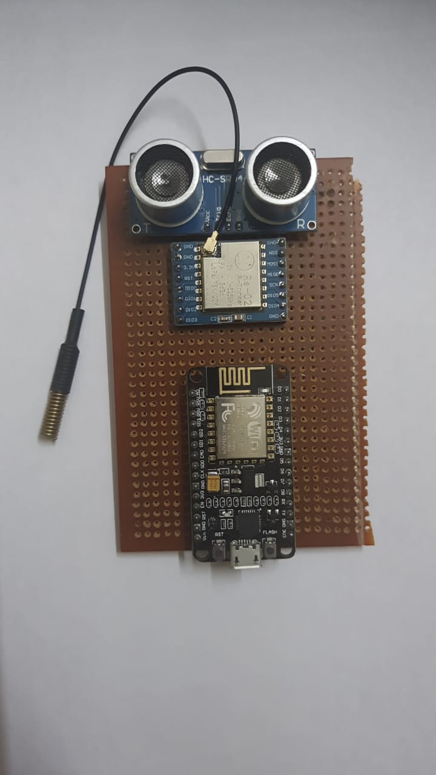

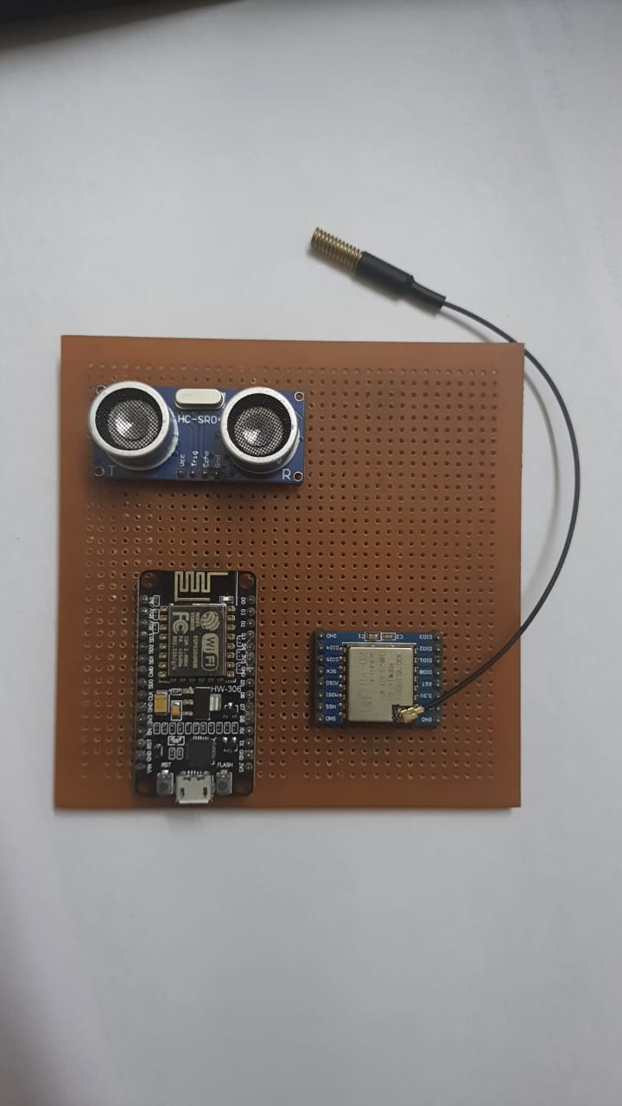

**SERIAL MONITOR OUTPUT:**

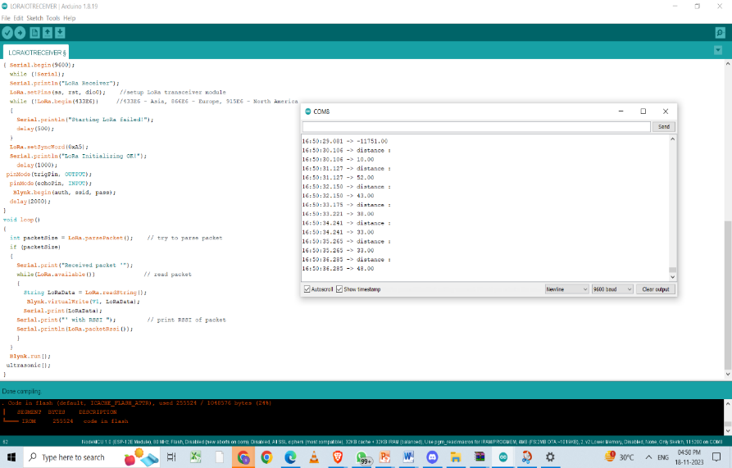

**CIRCUIT FOR RECEIVER:**

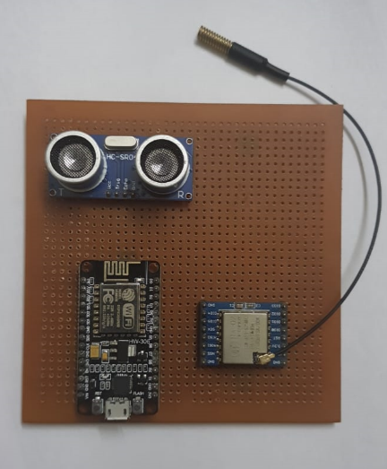

FINAL PRODUCT:

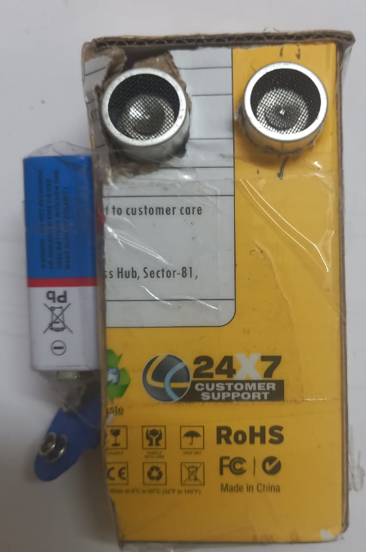



OUR WEB DASHBOARD:

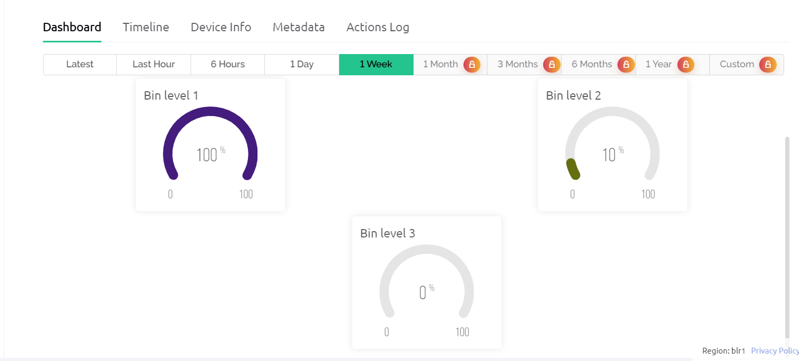

**OUR MOBILE APP PAGE:**

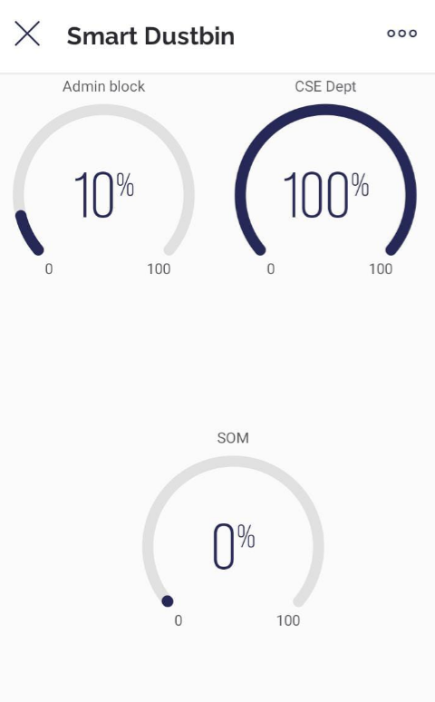

## **Conclusion:**

The Smart Dustbin Management System utilizing ESP8266 with LoRa communication and ultrasonic sensors offers an efficient and intelligent solution for waste management.

In conclusion, the Smart Dustbin Management System, powered by ESP8266 with LoRa communication and Blynk integration, represents a technological advancement in waste management. The combination of wireless communication, accurate sensor data, and an intuitive user interface creates a robust and scalable solution that not only addresses current challenges but also supports sustainable and efficient waste management practices. This system stands as a testament to the potential of IoT technologies in transforming traditional processes for the betterment of society and the environment.

The Smart Dustbin Management System offers an efficient and automated solution for waste management. By integrating ultrasonic sensors, LoRa communication, and the Blynk app, the system provides real-time monitoring of dustbin fill levels, optimizing waste collection routes, and contributing to a cleaner and more sustainable environment. This project showcases the potential of IoT technologies in addressing real-world challenges.

**FUTURE SCOPE:**

The future scope of a smart dustbin management system can be quite extensive, expanding beyond its initial implementation. Here are several potential avenues for future enhancements and applications:

### **1. Advanced Sensor Technologies:**

* **AI-Powered Sensors:** Implementation of AI or machine learning algorithms for more accurate waste level detection, categorization, and predictive analysis.

### **2. Smart Waste Sorting:**

* **Automated Sorting:** Integrating technologies for sorting recyclable and non-recyclable waste within the dustbin itself.

### **3. Energy Harvesting and Sustainability:**

* **Energy Efficiency:** Implementing energy harvesting techniques to power the system or improve overall energy efficiency.
* **Environmental Impact Analysis:** Collecting data to assess the environmental impact and efficiency of waste management practices.

### **4. IoT and Cloud Integration:**

* **Cloud-Based Monitoring:** Enhanced cloud-based monitoring systems for more extensive data storage, analytics, and remote management.

### **5. AI-Driven Waste Management Solutions:**

* **Optimization Algorithms:** Advanced algorithms for waste collection scheduling, dynamically adapting to changing waste volumes and patterns.

### **6. Augmented Reality (AR) and Virtual Reality (VR):**

* **Training and Maintenance:** Using AR/VR for maintenance, repair guidance, and staff training.
* **Using ESPNOW**: We can use ESPNOW and implement the prototype.

7. We would also like to automate our apps and send notifications to the respective dustbin collectors if its level is more to notify using gmail or an sms can be sent.

**References:**  
**1)** [1] Jenifer Prathana, IOT based smart garbage alert system using Arduino UNO, IEEE, November 2013

[2] Shashank Shukla, Smart waste collection System based on IOT, IJCA Vol. 132, and March 2017

[3] G. Anushri, Garbage Monitoring System Using Arduino, IJIRS Vol 8, April 2018.

[4] Resmi Rajendra, A Critical Review on Smart City Platform Development for Waste management, IJSART Vol 4, November 2018 [5] A.L.Hanees, IOT Based Waste collection monitoring system using smart phones, International Symposium2018 SEUSL.

[6] R. Manikandan, An Analysis of Garbage Mechanism for Smart cities, IRJET Vol 6, Jan 2019.

[7] Prof. Reena Sudhakar Rao Satpute, Smart Garbage Monitoring System using IOT based, IJARIIE Vol 4, Feb 2018.

[8] S. Jaya Kumar, Ultrasonic Assisted Smart Garbage Monitoring System, JNCET Vol 8, April 2018.

[9] M. Narayana, Smart Garbage Monitoring System Using Sensors with RFID over Internet Of Things, JARDC, Vol 9, June 2017.

[10] Md. Aasim Anwar, IOT based Garbage Monitoring using Arduino, RCC Institute of IT, May 2018.

[11] Praveen Kumar Gupta, The Use of modern technology in smart waste management system and recycling: artificial intelligence and machine learning, Research gate, April 2019 .

[12] S.S. Navghane, IOT based smart garbage and waste collection bin, IJARECE Vol 5, May 2013 [13] Countries With a Creative Approach to Trash Disposal.

[13]Smart Dustbin:

<https://ijirt.org/master/publishedpaper/IJIRT155879_PAPER.pdf>

[14] Design and Implementation of Different Types of Smart Dustbins System in Smart Campus Environments.

<https://www.atlantis-press.com/article/125946357.pdf>

[15] <https://randomnerdtutorials.com/esp-now-esp32-arduino-ide/>

### [**16**][Smart Waste Management Using Lora:](https://www.annalsofrscb.ro/index.php/journal/article/download/5741/4463/10418)

<https://www.annalsofrscb.ro/index.php/journal/article/download/5741/4463/10418>